Title: Repair Gas Leak | Candidate Written Exercise Rev.0
Title: Repair Gas Leak | Page 1 of 3

1.0 PURPOSE AND SCOPE
This task performs installation of gas seal leak repair kit for pinhole gas leaks on above or below ground steel pipe operating at 60 psig or less.
2.0 REFERENCES
Seal Gas Leak Repair Kit Manual
P-1605111314, Work Area Protection
3.0 PRECAUTIONS AND LIMITATIONS
Gloves shall be worn to prevent skin damage when handling Glass Outer wrap.
Working in and around a leaking pressurized natural gas pipe may result in injury.
4.0 PREREQUISITES
The following tools shall be used:
- Hand wire brush
- Leak detection soap solution
- Cold-applied tape wrap
- Clean rags
- Clean water
Seal Gas Leak Repair Kit Contents:
- Emery cloth
- Protective gloves
- Isopropyl cleaning wipe
- Solvent cleaning wipe
- Sealant putty
- Pressure sealing tape
- Glass Outer wrap
- Compression film

Title: Repair Gas Leak | Candidate Written Exercise Rev.0
Title: Repair Gas Leak | Page 2 of 3
5.0 INSTRUCTIONS
5.1 Preparation
- Establish work area protection in accordance with P-1605111314, Work Area Protection.
- Pinpoint the origin of the leak using a leak detection soap solution. When you are finished, wipe the area clean before proceeding with the repair. (Figure 1)
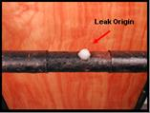
- Clean repair area using a wire brush to remove excess rust, dirt, or loose scale extending 3 to 4 inches on either side of the leak then roughen repair area using emery cloth to create a good bond to the sealant putty and wipe repair area clean with a solvent cleaning wipe.
  - Repair Application
- Remove foil end seals and outer packaging wrap from sealant putty. For approximately 2 minutes, knead putty until it is completely uniform in color (green) with no streaks. Mold sealant putty into a ¼-inch - 1/2" ball. Place sealant putty directly on pinhole leak. You will not use all of the putty.
- Using the following method, apply the entire roll of pressure sealing tape:
Anchor sealing tape on pipe adjacent to putty.
Simultaneously stretch the sealing tape to its maximum tension and wrap in an overlapping manner toward putty.
Remove excess putty that may push out from wrapping (refer to Figure 2).
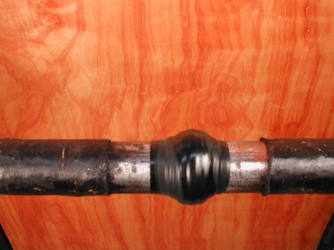
Title: Repair Gas Leak | Candidate Written Exercise Rev.0
Title: Repair Gas Leak | Page 3 of 3
  - Outer Wrap Application
NOTE
The joint must be completely sealed at this point.
- To apply the outer wrap, open the top of the foil packaging and submerge (approximately 10 seconds) so the package fills with water to activate the wrap material. Using the outer wrap, wrapping in the same direction as the pressure sealing tape, wrap the entire repair area extending 2 inches on either side of the pressure sealing tape (protective gloves required). After the entire repair area is wrapped with outer wrap, use gloved hands to squeeze and mold it firmly in the direction of the wrap until the outer wrap is tacky (approximately 5 minutes).
